Attachment D – Existing and Proposed LEP maps
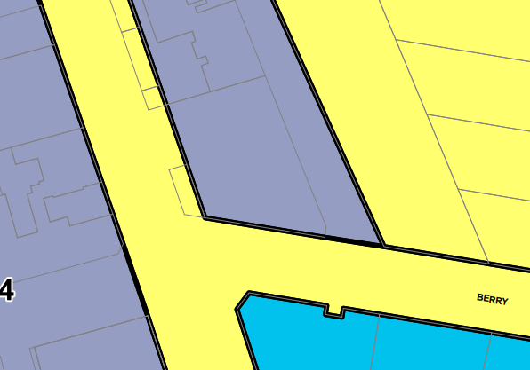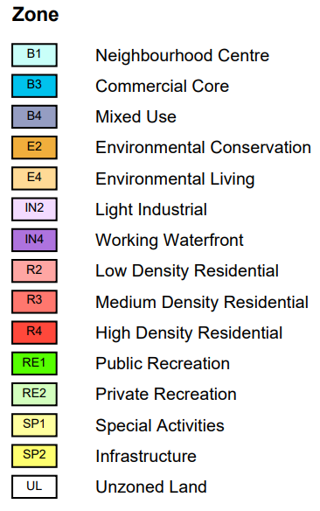
Subject site
Figure 1: Existing Land Zoning Map LZN_002A indicating a B4 Mixed Use zone (source: NSW Planning Portal)
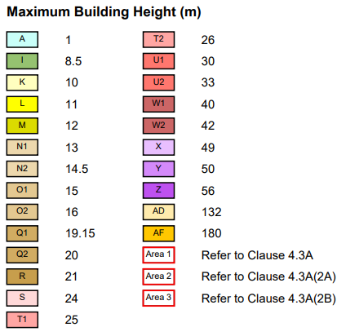
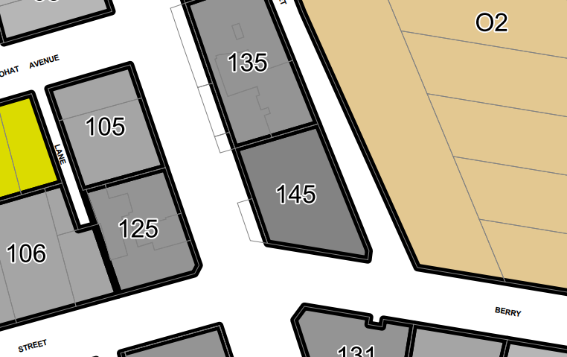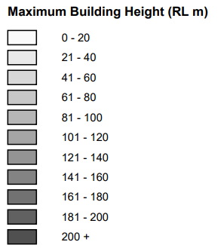
Subject site
Figure 2: Existing Height of Buildings Map HOB_002A indicating an existing height of RL145 (source: NSW Planning Portal)
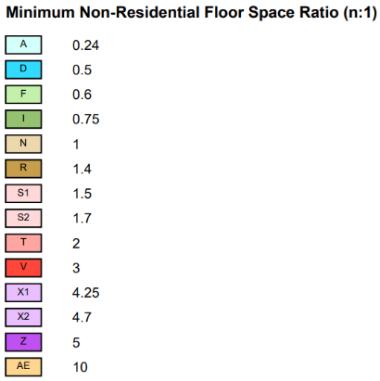
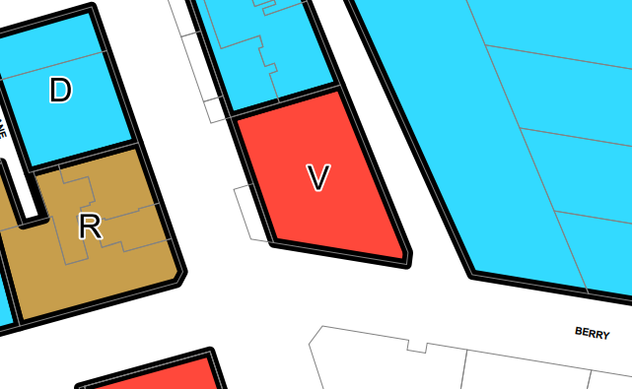
Subject site
Figure 3: Existing Non-Residential Floor Space Ration Map LCL_002A indicating the requirement of a non-residential FSR of 3:1 (source: NSW Planning Portal)
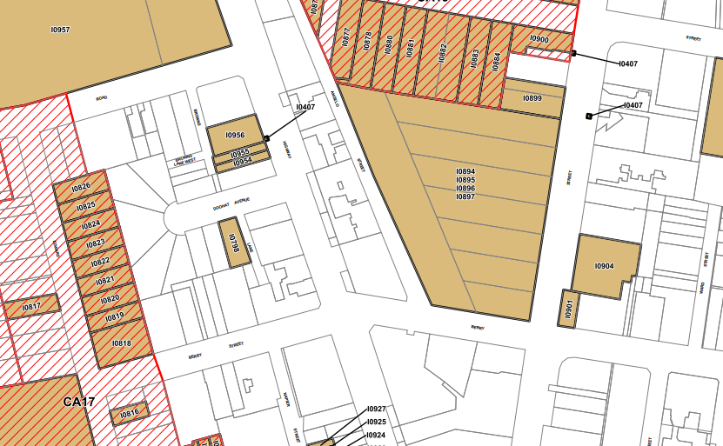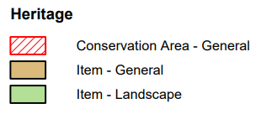
Figure 4: Existing Heritage Map HER_002A indicating that the site is in the vicinity of local heritage items (source: NSW Planning Portal)
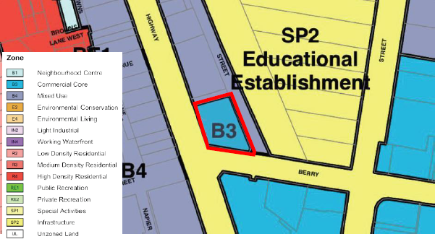
Figure 5: Proposed Land Zoning Map LZN_002A indicating a B3 Commercial Core Zone (source: Gyde)
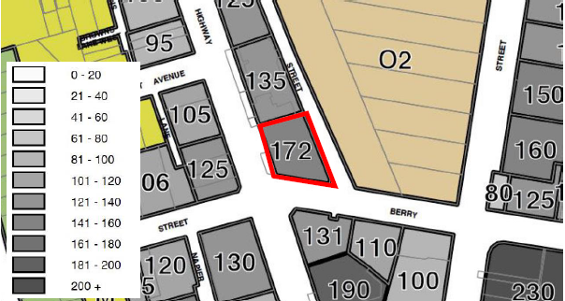
Figure 7: Proposed Height of Buildings Map HOB_002A indicating an existing height of RL172 (source: Gyde)
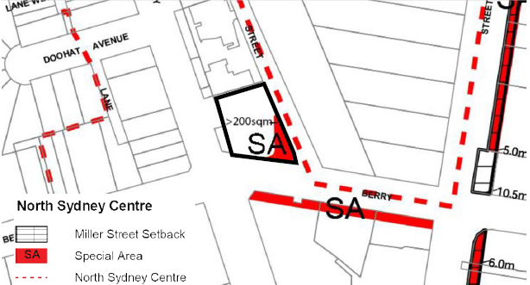
Figure 8: Proposed ‘special area’ (source: Gyde, Ward Street Masterplan)??? For where? This map from page 74 of the NOCPLAN (North of Centre) not Portal map or DCP Map. This is in the PP on page 52 – delete this or keep for panel?

